Test Case: tc001_SPX_Dev5_Crear_Requisicion_Spot_Tipo_Cobro_CC
Step 1 - Enter username and password and click to button Enter : Credentials Entered
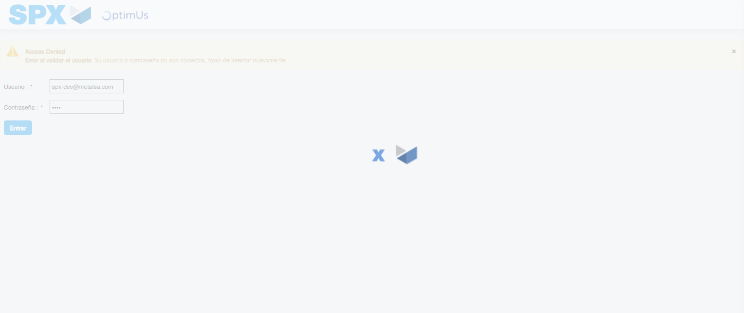Image file-name: QC_Testing-tc001_SPX_Dev5_Crear_Requisicion_Spot_Tipo_Cobro_CC-1783359148923

Step 2 - Select to UEN and Access to Spot Buy Requisitions : UEN Correctly selected and Correct access
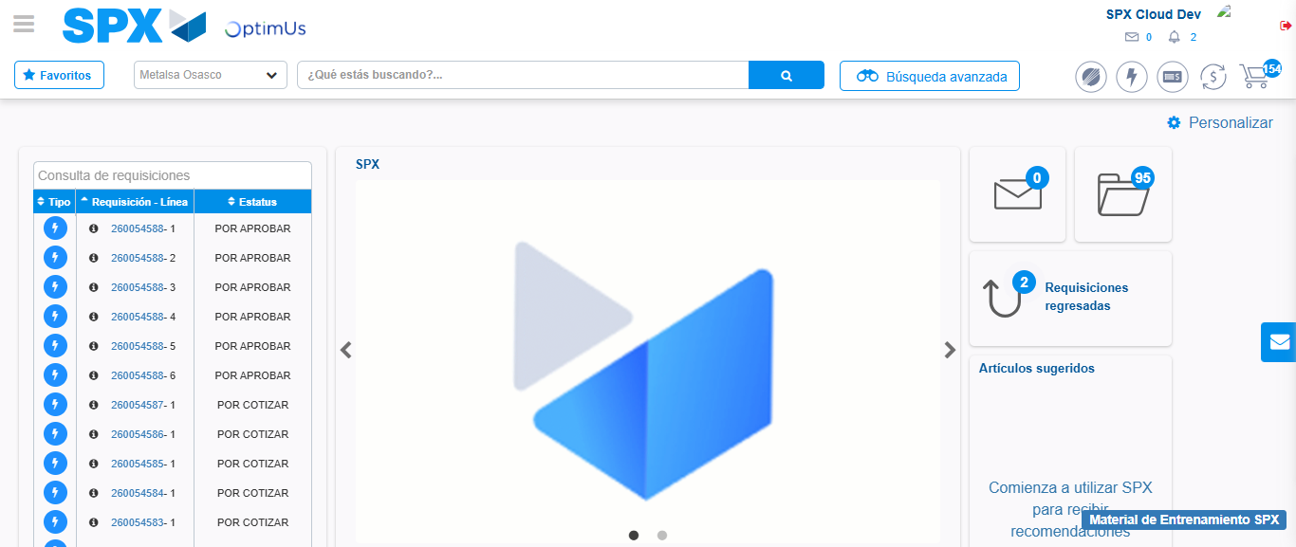Image file-name: QC_Testing-tc001_SPX_Dev5_Crear_Requisicion_Spot_Tipo_Cobro_CC-1783359174784

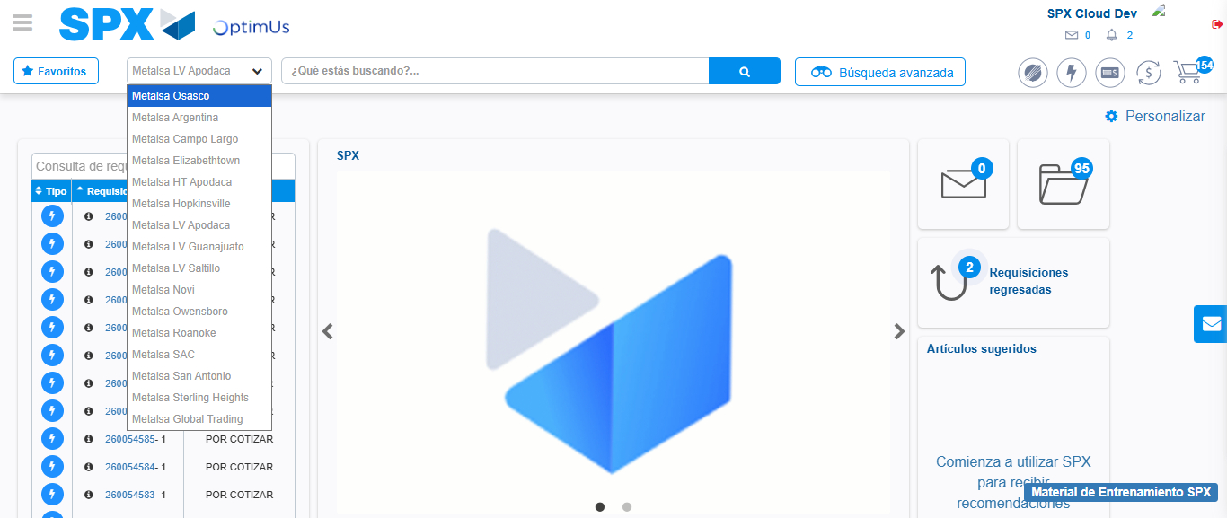Image file-name: QC_Testing-tc001_SPX_Dev5_Crear_Requisicion_Spot_Tipo_Cobro_CC-1783359177644

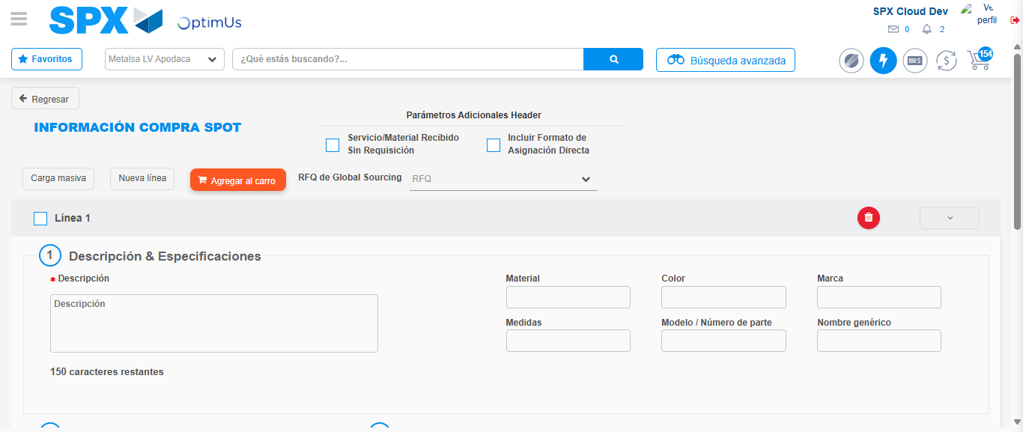Image file-name: QC_Testing-tc001_SPX_Dev5_Crear_Requisicion_Spot_Tipo_Cobro_CC-1783359198300

Step 3 - Data Capture Spot Buy Requisition : Data captured correctly
Image file-name: QC_Testing-tc001_SPX_Dev5_Crear_Requisicion_Spot_Tipo_Cobro_CC-1783359198592

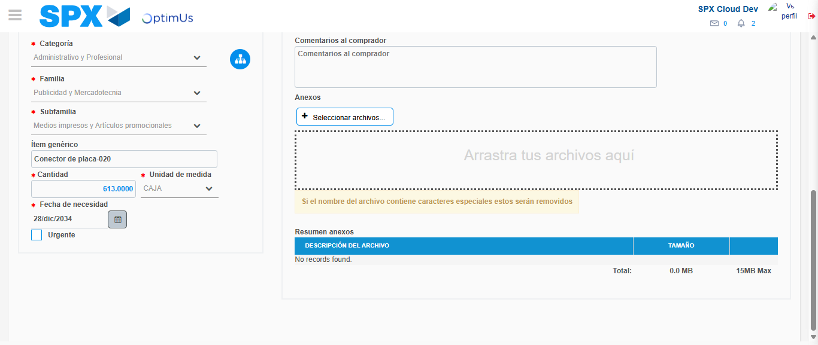Image file-name: QC_Testing-tc001_SPX_Dev5_Crear_Requisicion_Spot_Tipo_Cobro_CC-1783359211349

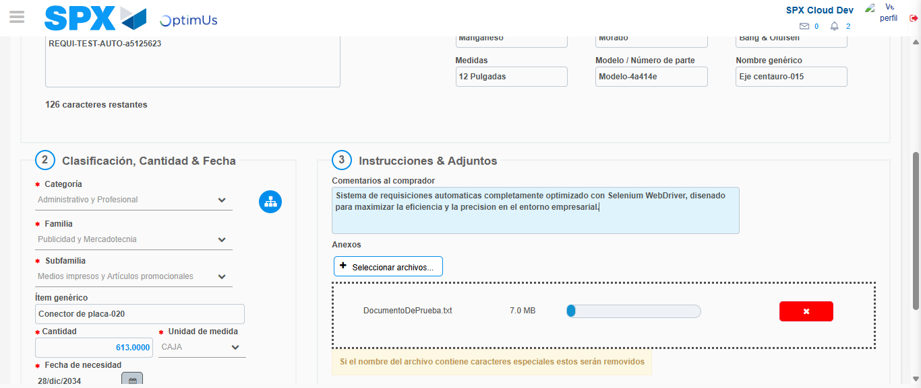Image file-name: QC_Testing-tc001_SPX_Dev5_Crear_Requisicion_Spot_Tipo_Cobro_CC-1783359212274

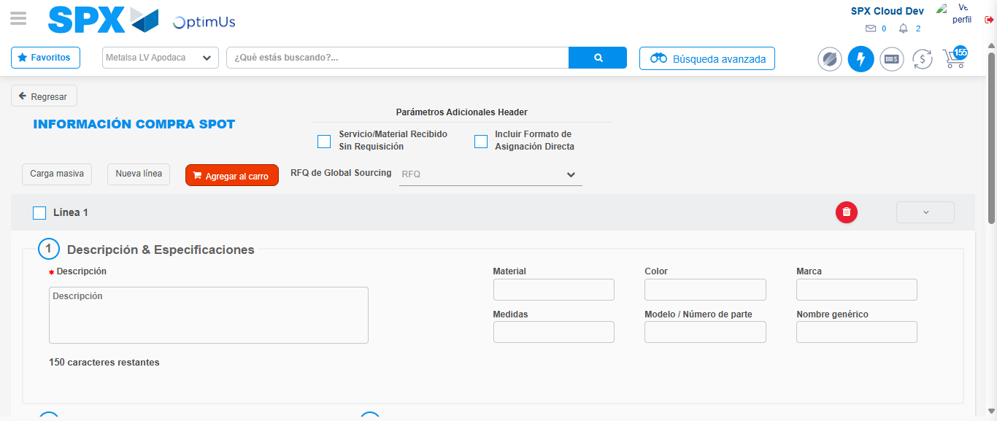Image file-name: QC_Testing-tc001_SPX_Dev5_Crear_Requisicion_Spot_Tipo_Cobro_CC-1783359224423

Step 7 - Return to Main Page SPX : Return to Main Page SPX
Image file-name: QC_Testing-tc001_SPX_Dev5_Crear_Requisicion_Spot_Tipo_Cobro_CC-1783359174784

Image file-name: QC_Testing-tc001_SPX_Dev5_Crear_Requisicion_Spot_Tipo_Cobro_CC-1783359177644

Image file-name: QC_Testing-tc001_SPX_Dev5_Crear_Requisicion_Spot_Tipo_Cobro_CC-1783359198300

Image file-name: QC_Testing-tc001_SPX_Dev5_Crear_Requisicion_Spot_Tipo_Cobro_CC-1783359226733

Image file-name: QC_Testing-tc001_SPX_Dev5_Crear_Requisicion_Spot_Tipo_Cobro_CC-1783359226924

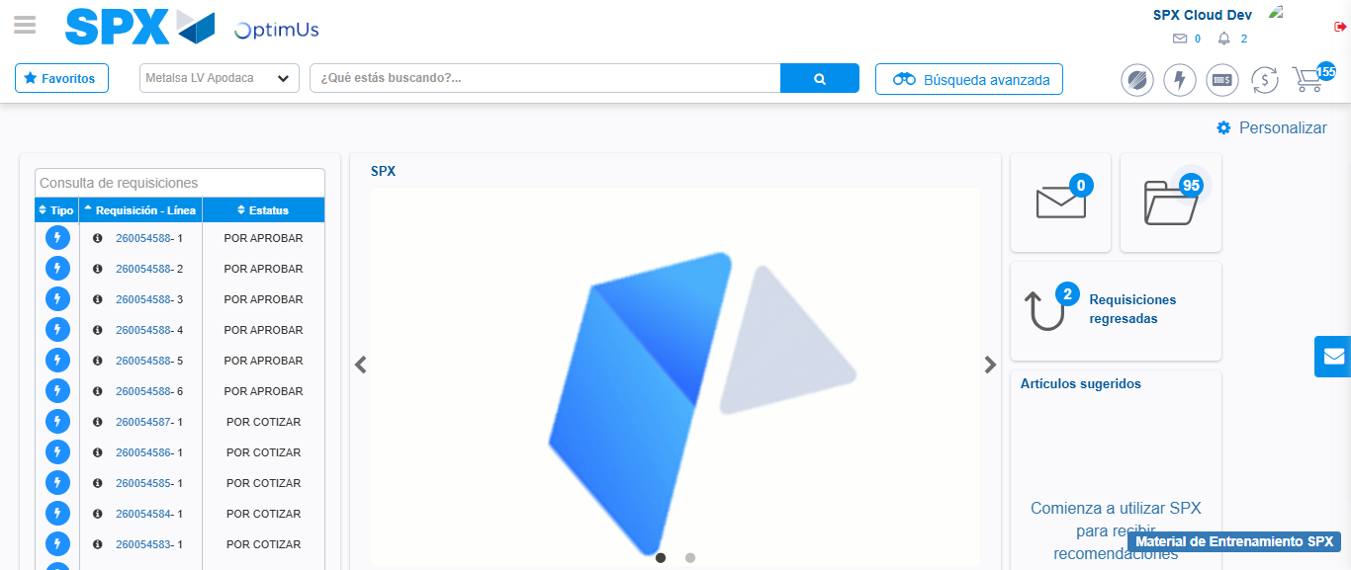Image file-name: QC_Testing-tc001_SPX_Dev5_Crear_Requisicion_Spot_Tipo_Cobro_CC-1783359248471

Step 8 - Log Out : Log Out SPX
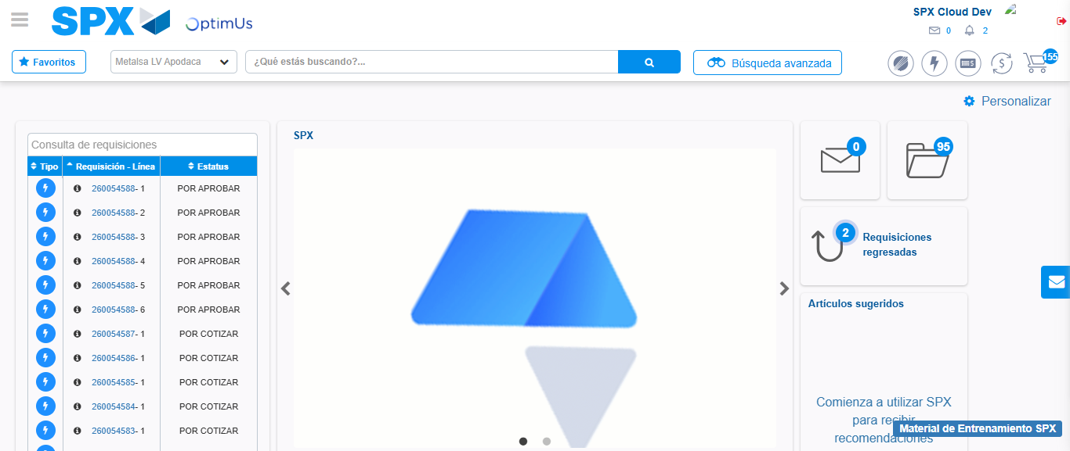Image file-name: QC_Testing-tc001_SPX_Dev5_Crear_Requisicion_Spot_Tipo_Cobro_CC-1783359248810

